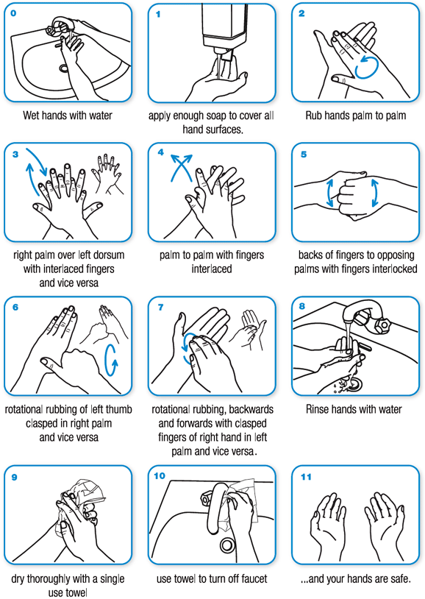 (WHO)
https://youtu.be/d914EnpU4Fo (CDC video on washing hands)
Be sure to remove jewelry and wash those items as well as your hands. Germs can get stuck between watches and skin, rings and skin, etc.

