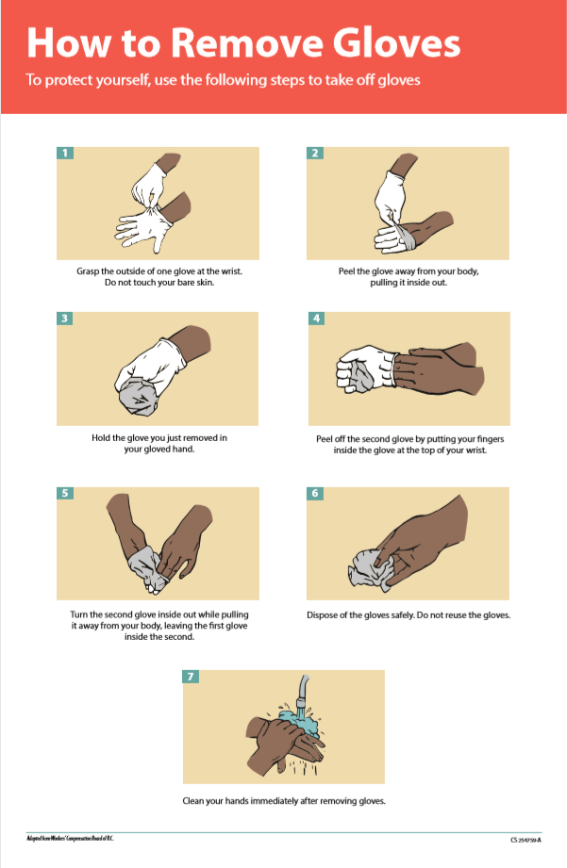
A plastic bag can make a good alternative if you don’t have gloves.

